CU JUT ETHNIC MINORITY BOARDING SCHOOL ‘S ENGLISH CLUB ESTABLISHMENT
English 's very important to us. To inspire English learning for students, on a Monday afternoon of January 25th, 2021, Cu Jut Ethnic Boarding school 's English club was established.

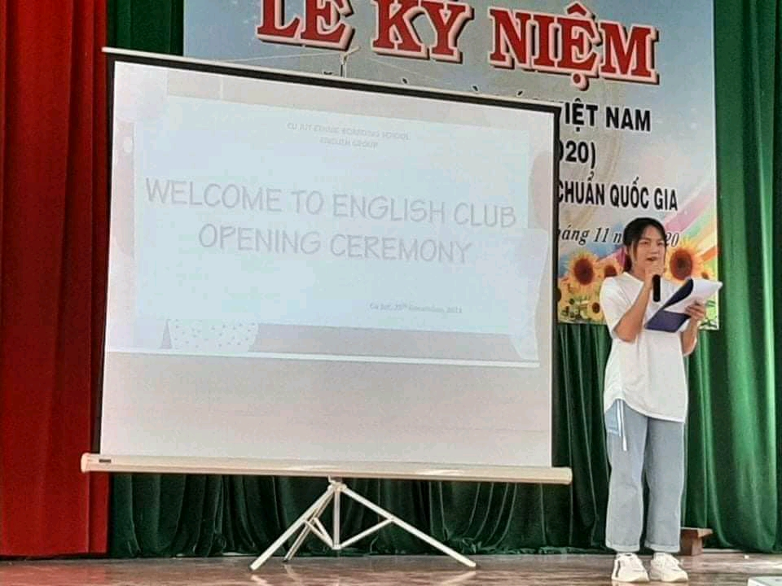
The English club opening ceremony had the participation of school’s leaders, the Social - Sciences group 's teachers and all of the students. 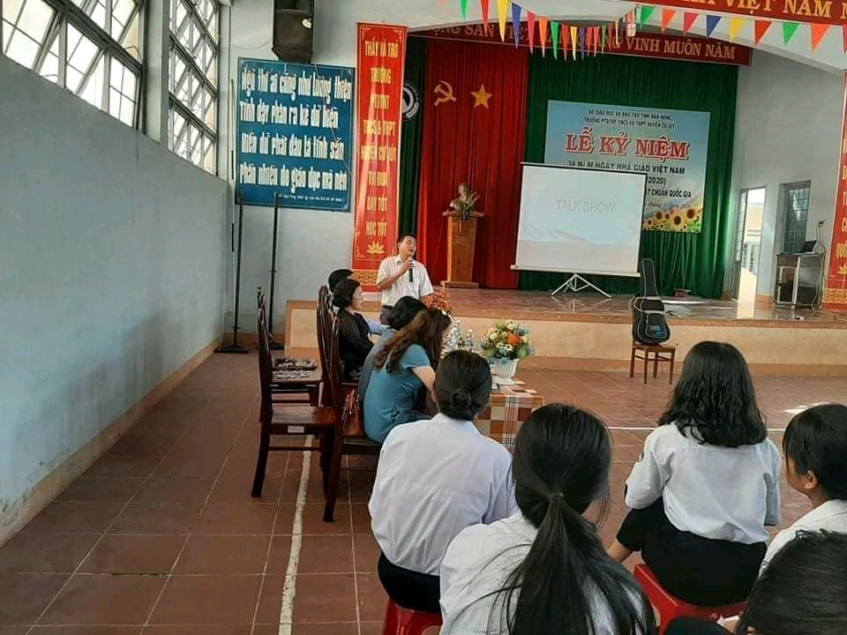
Leaders of English club include:
Mrs. Nguyen My Huong – Chairman of the club
Mrs. Truong Thi My Hien - club vice president
Ms. Hoang Thi Anh, Ms. Hoang Thi Cuc Hoa, Ms.Nghiep, Ms. Hoang Thi Chi Phuong, Ms. Bich Khue, Ms. Thu Ha are commissaries. The English club was created for the purpose of improving English process of the students, especially, speaking skill; helping those who are passionate about English to have conditions to develop; helping those who want to learn English well, the wish will be made. When taking part in the English club, you can get to know new friends, feel happy, and confident, love English, have life skills and make you more sociable

more.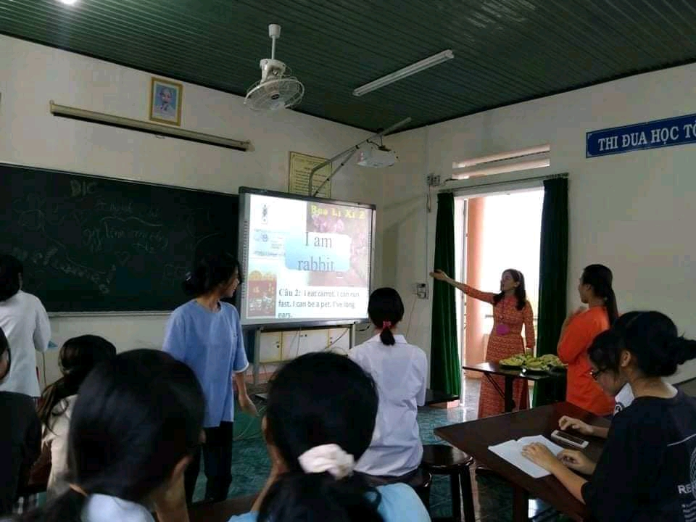 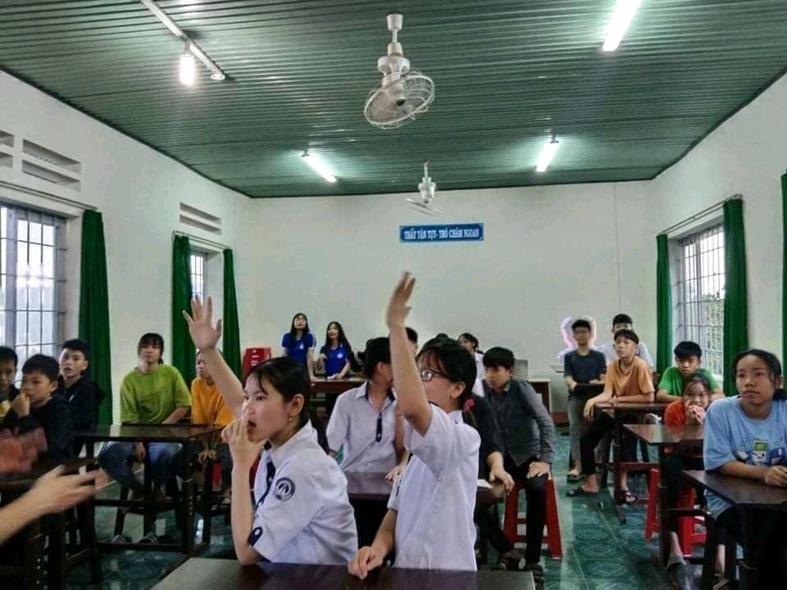
By participating in the English club, you can enjoy lots of joys and knowledge on off line meeting with many different topics such as: Introducing myself; Favorite dishes; My school; My music; My dream; My friendship,.... You can play while studying, talk about topics and play games, talk to your friends in English and sing tEnglish songs,.... Besides, you can talk with English teachers. you will be naturally expressing all your broblems while learning English with your favorite teachers.
Do English club have many benefits for you?
Please join the English club now! Wish you all good study!
Wish English club more florish and success!
Everybody please support and follow English club by page below.
https://www.facebook.com/English-group-of-C%C6%B0jut-Boarding-chool-NEVER-GIVE-UP-100231312091056/

